**HIRING INTERNS DATABASE**

**PROJECT MEMBERS:**

ASHISH(20/49017)

YOGITA(20/49030)

**ER DIAGRAM**

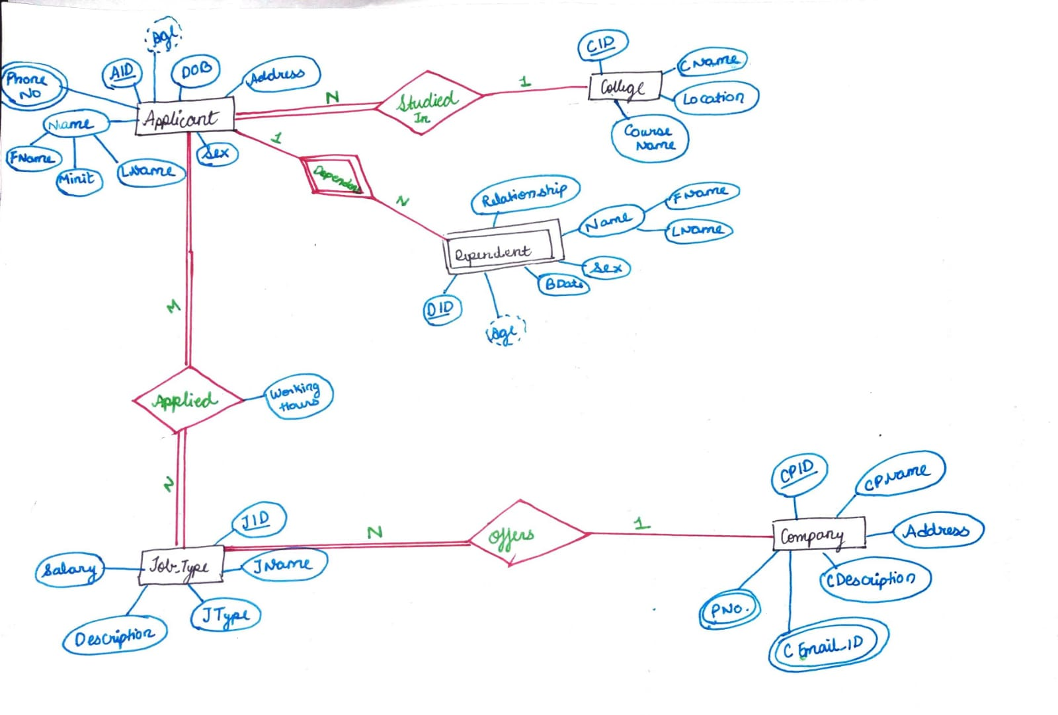

**MAPPING OF ER DIAGRAM**

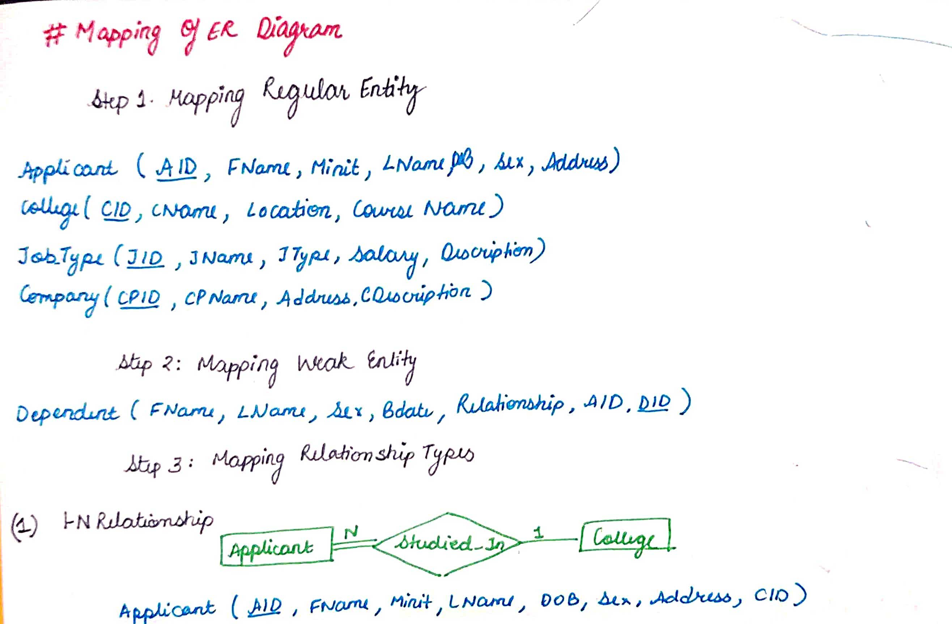

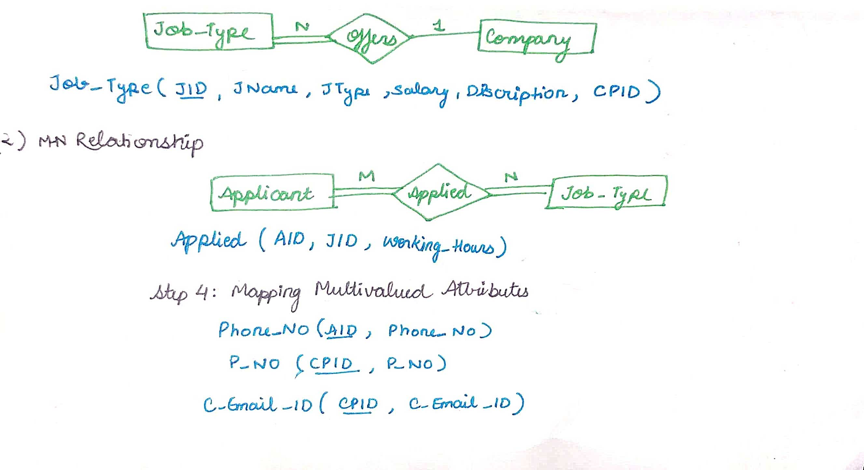

**SCHEMA**

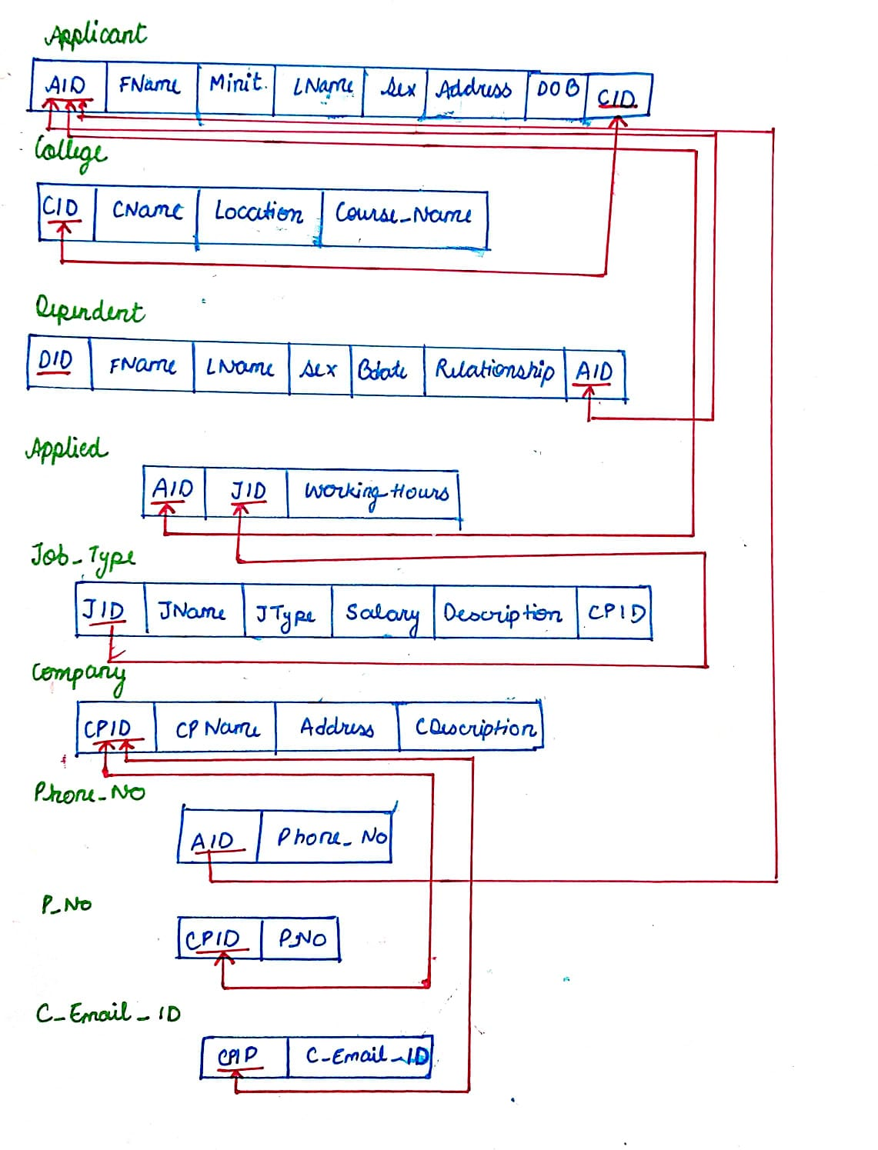

**COLLEGE**

CREATE TABLE COLLEGE(

-> CID VARCHAR(10) NOT NULL,

-> CNAME VARCHAR(20),

-> LOCATION VARCHAR(20),

-> COURSE_NAME VARCHAR(20),

-> PRIMARY KEY(CID));

**APPLICANT**

CREATE TABLE APPLICANT(

-> AID VARCHAR(10) NOT NULL,

-> FNAME VARCHAR(20) NOT NULL,

-> MNAME VARCHAR(20),

-> LNAME VARCHAR(20),

-> SEX VARCHAR(5),

-> ADDRESS VARCHAR(20) NOT NULL,

-> DOB DATE NOT NULL,

-> CID VARCHAR(10) NOT NULL,

-> PRIMARY KEY(AID),

-> FOREIGN KEY(CID) REFERENCES COLLEGE(CID));

**DEPENDENT**

CREATE TABLE DEPENDENT(

-> DID VARCHAR(10) NOT NULL,

-> FNAME VARCHAR(20) NOT NULL,

-> LNAME VARCHAR(20),

-> SEX VARCHAR(5),

-> BDATE DATE NOT NULL,

-> RELATIONSHIP VARCHAR(15) NOT NULL,

-> AID VARCHAR(10) NOT NULL,

-> PRIMARY KEY(DID),

-> FOREIGN KEY(AID) REFERENCES APPLICANT(AID));

**COMPANY**

CREATE TABLE COMPANY(

-> CPID VARCHAR(10) NOT NULL,

-> CPNAME VARCHAR(20) NOT NULL,

-> ADDRESS VARCHAR(20) NOT NULL,

-> CDESCRIPTION VARCHAR(20),

-> PRIMARY KEY(CPID));

**JOB_TYPE**

CREATE TABLE JOB_TYPE(

-> JID VARCHAR(10) NOT NULL,

-> JNAME VARCHAR(10) NOT NULL,

-> JTYPE VARCHAR(15) NOT NULL,

-> SALARY DECIMAL(10,2),

-> DESCRIPTION VARCHAR(15),

-> CPID VARCHAR(10) NOT NULL,

-> PRIMARY KEY(JID),

-> FOREIGN KEY(CPID) REFERENCES COMPANY(CPID));

**APPLIED**

CREATE TABLE APPLIED(

-> AID VARCHAR(10) NOT NULL,

-> JID VARCHAR(10) NOT NULL,

-> WORKING_HOURS DECIMAL(3,1) NOT NULL,

-> FOREIGN KEY(AID) REFERENCES APPLICANT(AID),

-> FOREIGN KEY(JID) REFERENCES JOB_TYPE(JID));

**PHONE_NO**

CREATE TABLE PHONE_NO(

-> AID VARCHAR(10) NOT NULL,

-> PHONE_NO INT,

-> FOREIGN KEY(AID) REFERENCES APPLICANT(AID));

**P_NO**

CREATE TABLE P_NO(

-> CPID VARCHAR(10) NOT NULL,

-> P_NO INT,

-> FOREIGN KEY(CPID) REFERENCES COMPANY(CPID))

**C_EMAIL_ID**

CREATE TABLE C_EMAIL_ID(

-> CPID VARCHAR(10) NOT NULL,

-> C_EMAIL_ID VARCHAR(20) NOT NULL,

-> FOREIGN KEY(CPID) REFERENCES COMPANY(CPID));

**SHOWING TABLES THROUGH DESC COMMAND**

**DESC APPLICANT**

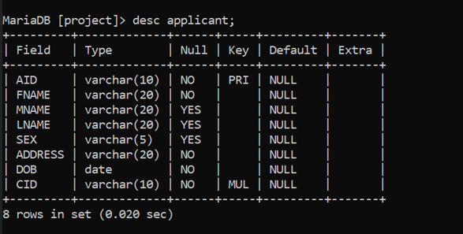

DESC APPLIED

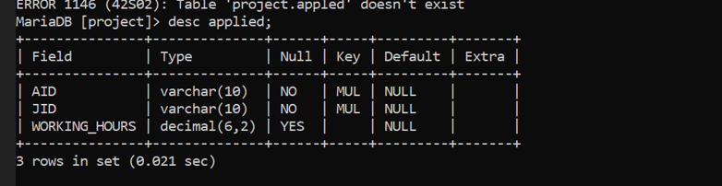

DESC C_EMAIL_ID

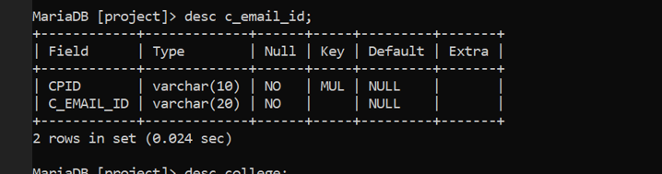

DESC COLLEGE

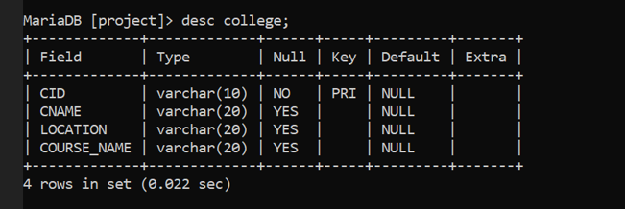

DESC COMPANY

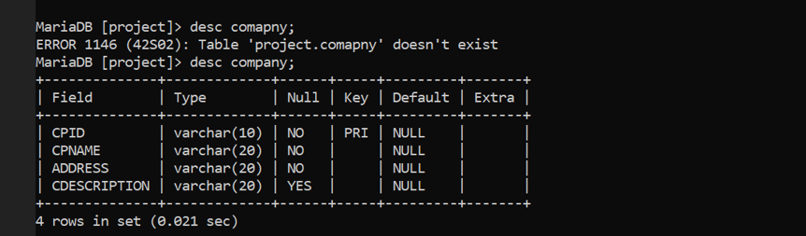

DESC DEPENDENT

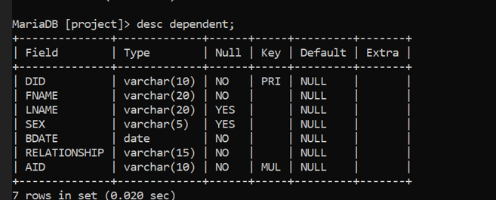

DESC JOB_TYPE

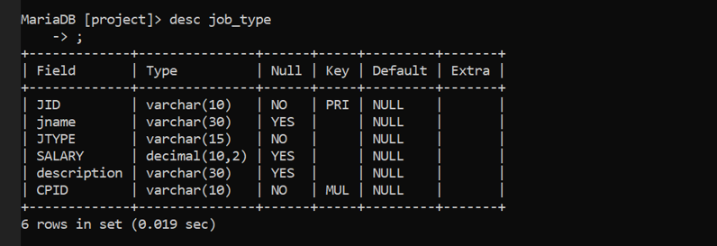

DESC P_NO

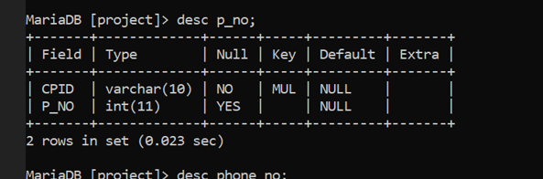

DESC PHONE_NO

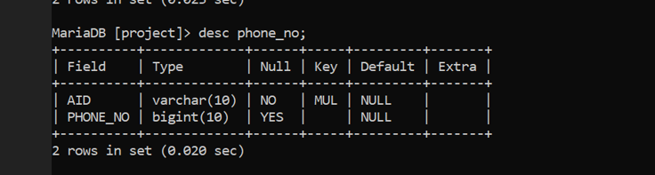

**SHOWING DATA IN TABLES THROUGH SELECT COMMAND**

**SELECT * FROM APPLICANT**

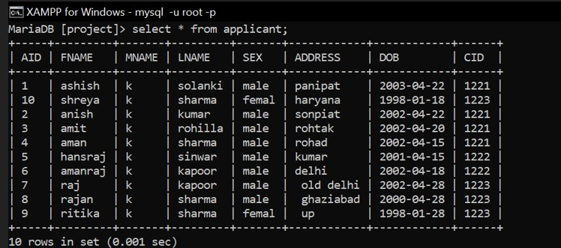

**SELECT * FROM PHONE_NO**

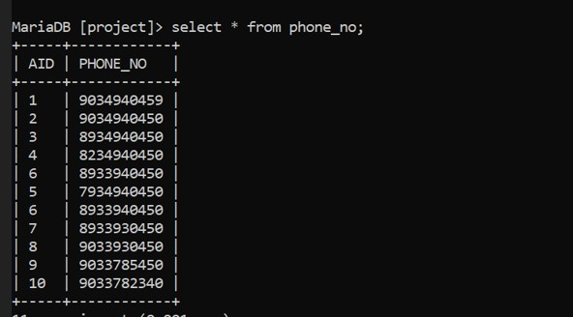

**SELECT * FROM P_NO**

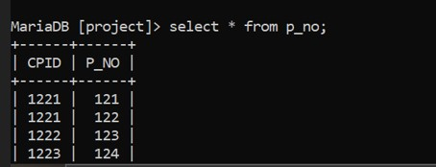

**SELECT * FROM JOB_TYPE**

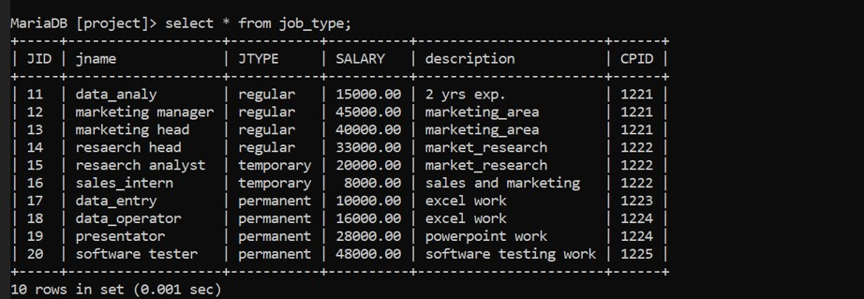

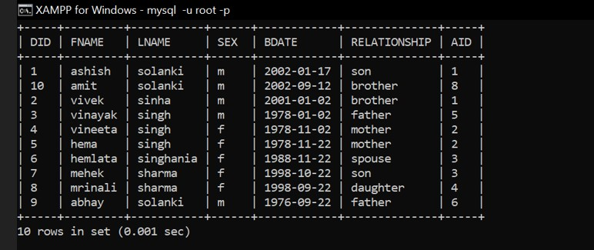

**SELECT * FROM COMPANY**

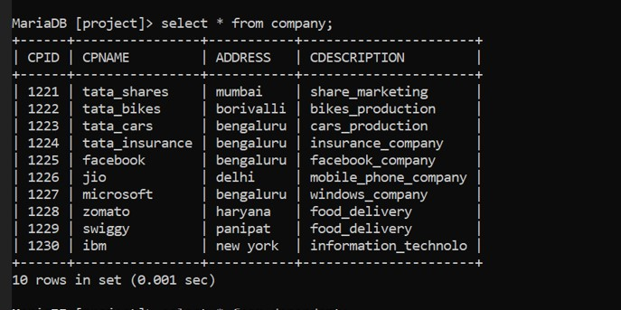

**SELECT * FROM C_EMAIL_ID**

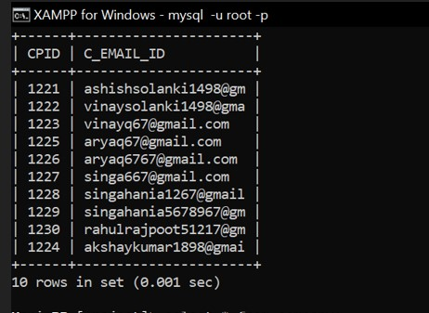

**SELECT * FROM APPLIED**

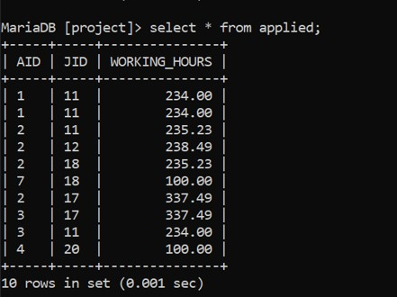

**SELECT * FROM COLLEGE**

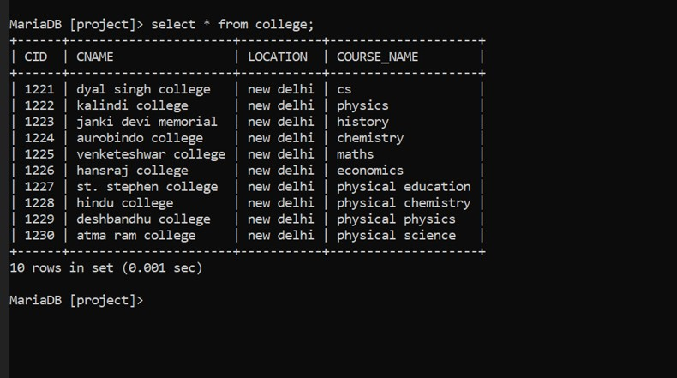

**QUERIES**

Query 1 Query to display name of applicant who born in 2000.

SELECT CONCAT (‘FNAME’,’ ’,’MINIT’,’ ’,’LNAME’), DOB FROM APPLICANT WHERE BDATE=’2003’;

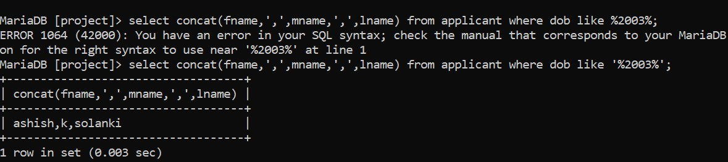

QUERY 2 Display total no. of company at each location.

SELECT COUNT (DISTINCT CPID), ADDRESS FROM COMPANY GROUP BY ADDRESS;

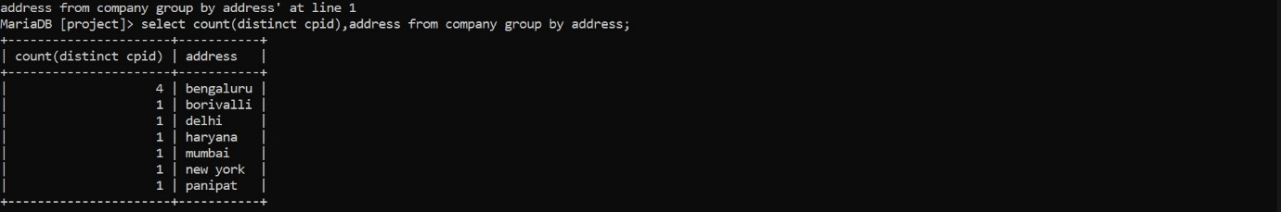

QUERY 3Query to display name with 1st letter capitalized and all other letter lower case and length of first name who name starts with ‘A’.

SELECT CONCAT (UPPER (SUBSTRING(FNAME,1,1)),LOWER (SUBSTRING(FNAME,2))) AS NAME , LENGTH (FNAME) AS LENGTH FROM APPLICANT WHERE FNAME LIKE ’A%’;

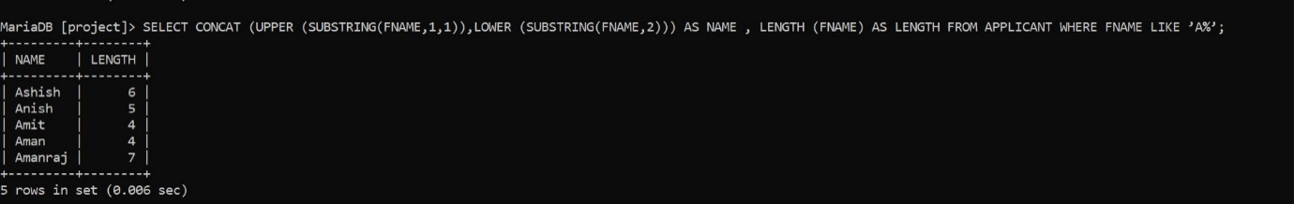

QUERY 4 Display the average salary in the department.

SELECT COUNT(JOB_TYPE.JTYPE) AS TYPE_OF_JOB, JOB_TYPE.JNAME,AVG(SALARY) AS AVERAGE_SALARY FROM JOB_TYPE, COMPANY WHERE COMPANY.CPID=JOB_TYPE.CID GROUP BY JTYPE;

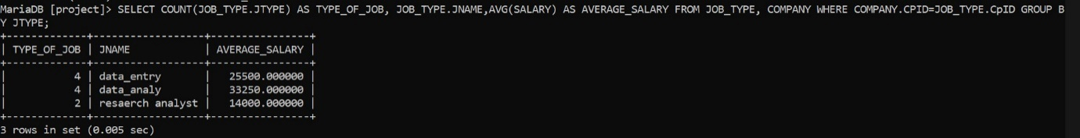

QUERY 5 Display unique Job type.

SELECT DISTINCT(J_TYPE) FROM JOB_TYPE;

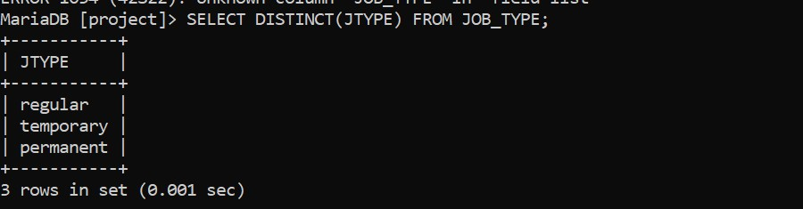

QUERY 6 Display the details of dependents of the applicant who have qualified from DSC.

SELECT * FROM DEPENDENT WHERE APPLICANT.AID=DEPENDENT.AID AND APPLICANT.CID=COLLEGE.CID;

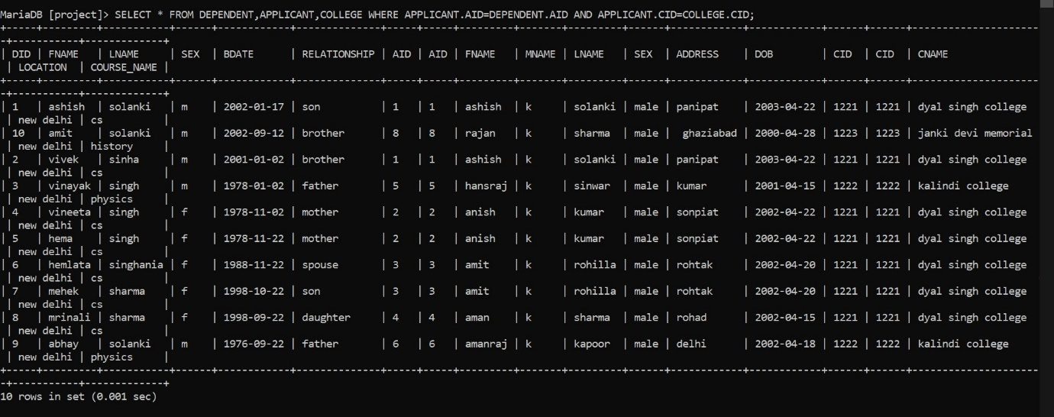

QUERY 7 Display the details of company where job type is permanent along with salary.

SELECT COMPANY.CPID,COMPANY.CPNAME,COMPANY.ADDRESS,COMPANY.CDESCRIPTION, JOBTYPE.SALARY FROM COMPANY, JOB_TYPE WHERE JOB_TYPE.CPID=COMPANY.CPID AND JTYPE=”PERMANENT”;

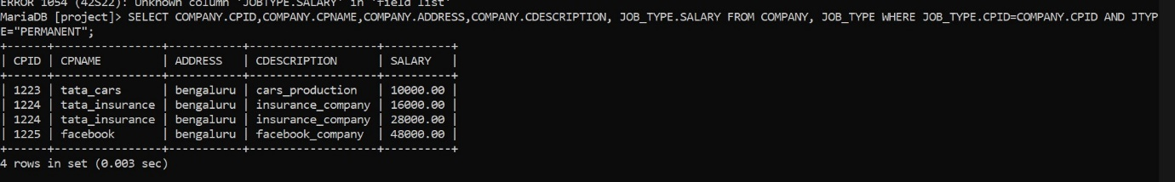

QUERY 8 Query to display the details of applicant whose working more than 250.

SELECT * FROM APPLICANT WHERE APPLICANT.AID=APPLIED.AID AND WORKING_HOURS>250;

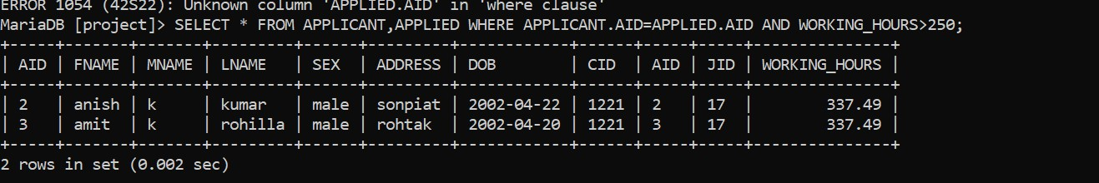

**QUERY 9 DISPLAY THE NAMES WITH TWO A OR TWO I**

**SELECT FNAME FROM APPLICANT WHERE FNAME LIKE '%A%A%' OR FNAME LIKE '%I%I%' ;**

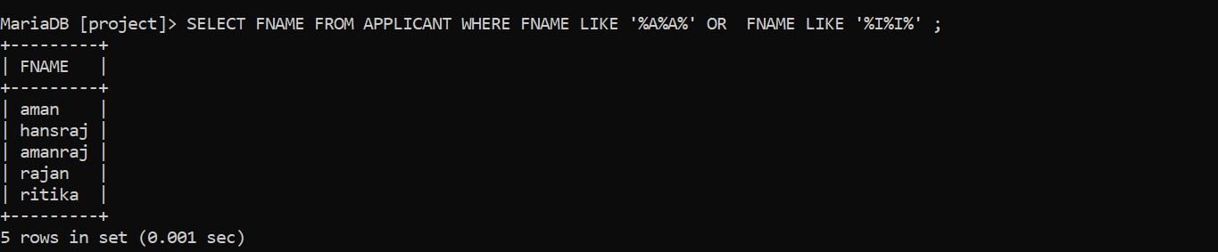

**GUI**





